Lab - Region and Language Options in Windows 7 and Vista

Introduction
In this lab, you will examine regional and language settings in Windows 7 and Windows Vista.

Recommended Equipment
- A computer running Windows 7 or Vista
    - Open with the Region and Language settings on your PC.
      - Log on to the computer.
      - Click Control Panel > Region and Language.
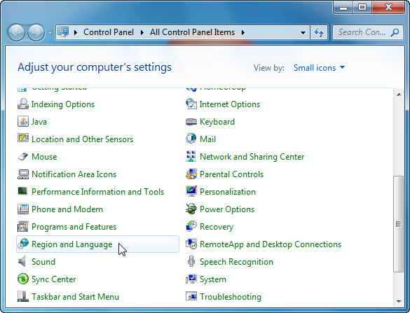
      - The Region and Language window opens.
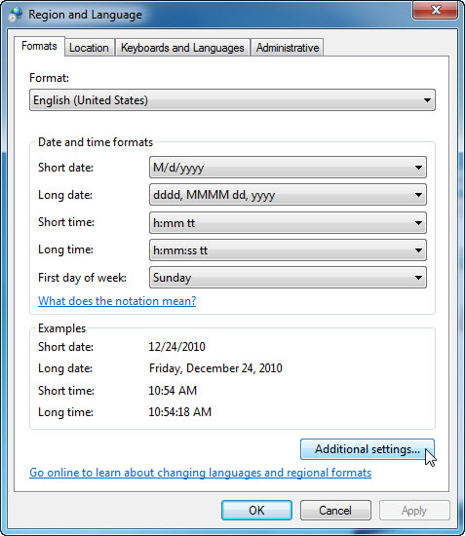
What regional format is being used?
____________________________________________________________________________________
____________________________________________________________________________________
      - Click Additional settings. The Customize Format window opens.
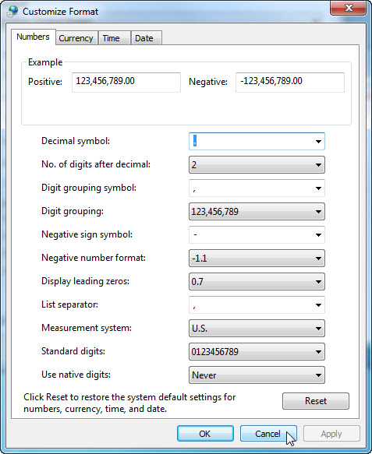
What are the tabs that can be customized?
____________________________________________________________________________________
      - Click Cancel.
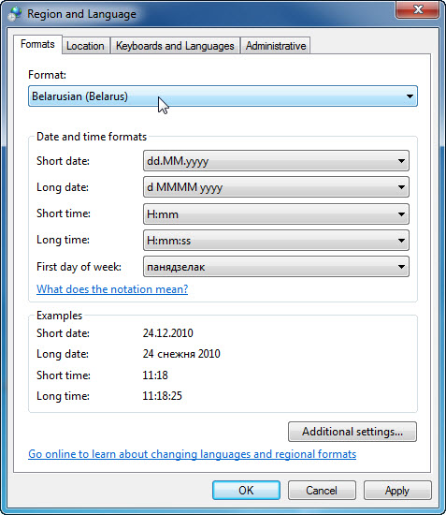
      - Select Belarusian (Belarus) in the Format drop-down menu. Notice the changes to the output in the Examples area of how data is displayed using this format.
Note: In Windows Vista, select Belarusian (Belarus) in the Current Format drop-down menu.
      - Choose the original setting from the Format drop-down box. Click the Keyboards and Languages tab, and click the Change keyboards… button
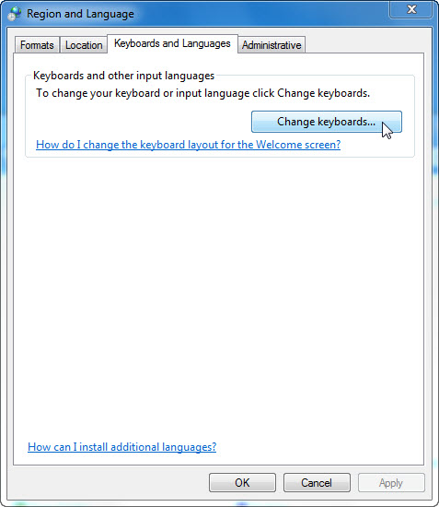
      - The Text Services and Input Languages window opens. Click Add.
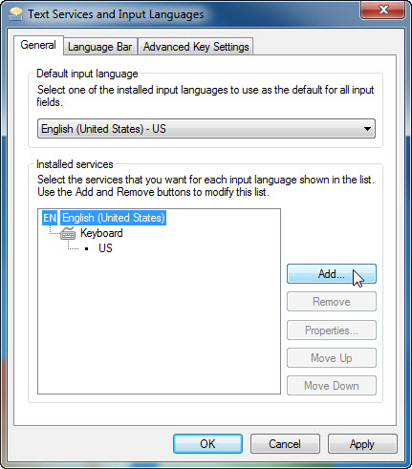
      - The Add Input Language window opens. Scroll down the list of options and click Belarusian (Belarus) > Keyboard. Check US and click OK.
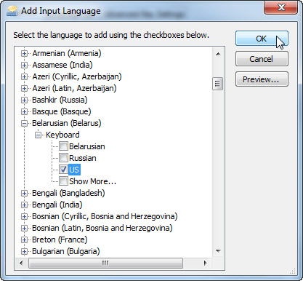
      - In the Text Services and Input Languages window, click Apply to accept the changes.
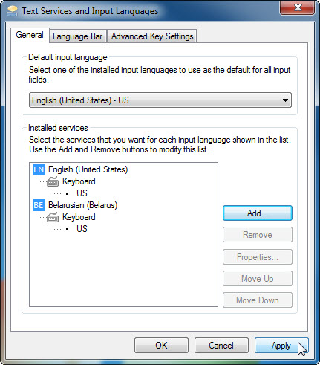
What is the default input language?
____________________________________________________________________________________
      - Close all open windows.
    - Set the Language bar to appear on the Taskbar.
      - Right-click the Taskbar.
      - Select Toolbars > Language bar to ensure that the Language bar is shown in the Taskbar.
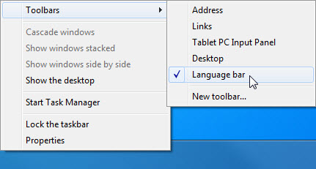
      - Right-click the Language bar in the Taskbar. Click Settings.
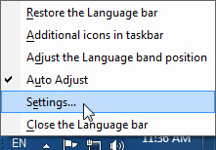
      - The Text Service and Input Languages window opens. Select the keyboard that was added. Bengali (Bangladesh), and then click Remove > OK
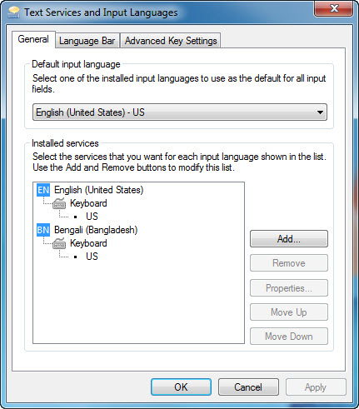
      - Close all open windows.

